Artificial intelligence as situated action: A scoping review
Jakub Mlynář, Lynn de Rijk, Andreas Liesenfeld, Saul Albert, Wyke Stommel, Renata Topinková

WORK IN PROGRESS – PRELIMINARY DRAFT. NOT FOR DISTRIBUTION, CIRCULATION, QUOTATION OR CITATION.

Abstract
This article reviews four decades of research on situated uses of AI-related technologies. Reviewing over 90 peer-reviewed publications, we map how studies of various AI-related “social” technologies that take an observational, empirical, and human-centered perspective have been applied to dialog systems, chatbots, voice user interfaces, and various types of robots. Following the pioneering work of Lucy Suchman, we find that such studies on technology related to the ethnomethodological and conversation analytic research tradition have addressed all steps of the technology lifecycle, from conceptualization, to design, evaluation, and implementation, to adoption in social life and societal impact. We discuss a citation network that tracks work in this field throughout the past 50 years, showcasing both the diversity and influential work of the field, as well as how authors, the topics of their studies, and the population they study relate and develop. We find that the reviewed studies focused on various social and group activities, such as task-oriented interactions, semi-experimental setups, play, and everyday interactions. The studies also include various populations, including children, older participants, and people with disabilities. We summarize the contribution of studies of situated action to various disciplines such as engineering, healthcare, philosophy as well as various strands of the social sciences, and conclude by highlighting some directions for future research.

1. Introduction
The expansion of technologies based on artificial intelligence (AI) is one of the most consequential social developments of the last two decades (Collins 2018; Elliot 2019). As AI increasingly encroaches on our everyday lives, we find new ways of interacting with such technologies. Reviewing studies of social interaction and sense-making with and around AI-based devices, this article puts forward an alternative conceptualization of AI as situated action, following Suchman’s (1987) appeal to study interactive artifacts by looking at “how it is that actors use the circumstances that a particular occasion provides … to provide for their action’s developing purpose and intelligibility.” (p. 4–5).
Scientific engagement with artificial intelligence spans many disciplines, from those invested in advancing technology, to others critically examining the effects, risks and implications of AI. In this paper we offer a complementary but distinct take on the relationship between AI and social life. Rooted in a longstanding tradition of detailed and systematic empirical studies of human sociality and social interaction, this review offers a primer and overview of AI-based technologies in situated use. Studies of situated action center the human and explore what people do with such technologies: do “smart devices” and “intelligent machines” present a profound transformation of the world? How do they impact the way we live and work together? Building on foundational work by Harold Garfinkel (1967, 2002, 2022), Harvey Sacks (1992) and others involved in constituting the fields of ethnomethodology and conversation analysis (EM/CA), this approach to understanding human interaction with and through technology has not only stood the test of time, but has also enriched fundamental research at the intersection of social organization and linguistic interaction (for introductions, see e.g., ten Have, 2007; Hester and Francis, 2004; Sidnell and Stivers, 2012).
Through this interaction-centered approach, studies in EM/CA have explored, for example, mathematicians’ interactions while doing math (Livingston, 1986), how scientists ‘do’ science (Lynch, 1993; Garfinkel, 2022) and how developers do software development (Suchman & Trigg, 1993). This interactional approach offers insights to technical fields covering the whole spectrum from inception to design and evaluation. Similarly, since its earliest studies of talk on the phone (e.g., Schegloff, 1968), EM/CA has offered a stimulating perspective on interactive technologies as tools and study settings that enable new discoveries by revealing the intricate workings of interactional processes (Heath & Luff, 2022). As AI technologies are increasingly ‘routinized’ and pervasive (Hirsch-Kreinsen, 2023), studies of AI within situated social action have grown into a substantial corpus of work that maps and tracks how these technologies have interacted with everyday social life over more than three decades. Within the wider field of human-computer interaction (HCI), these studies have contributed a systematic, reflexive focus on how interactions unfold in ways that are demonstrably consequential for users (Reeves, 2019), by looking at how these technologies enables and constrains universal mechanisms and norms of everyday social interaction (Mlynář et al., 2018). However, while remaining highly influential and inherently related, these studies are scattered across several fields and have appeared under various methodological, topical, and field-specific banners including not only EM and CA, but also computer supported collaborative working (CSCW), institutional ethnography, workplace studies, and interactional linguistics. This paper is an initial attempt to bring parts of this disperse body of work together, and to begin tracing its broader trends and directions in order to consolidate its most significant findings and distinctive contributions to the broader field of social studies of AI.
For the present scoping review, we have collected 93 scientific communications that apply analytic principles inspired by EM/CA to study AI in interaction, and we take stock of their specificity, contributions, and preoccupations. These approaches develop ethnomethodological sensitivity to the temporal organization of social action and practical reasoning in professional and everyday activities. There is a long thread of such research in computing, technology, and interacton with, through, and around machines (e.g. Sudnow, 1983; Suchman, 1987; Button et al. 1995; Dourish & Button, 1996), including AI specifically (e.g., Gilbert & Heath, 1985; Coulter, 2008). The growing availability and diffusion of AI-based technologies have led to an apparent trend in the number of naturalistic observational studies on AI-related topics. This trend is illustrated by Figure 1, which shows the number of items in the corpus for each year that we have sampled as a basis for the review.
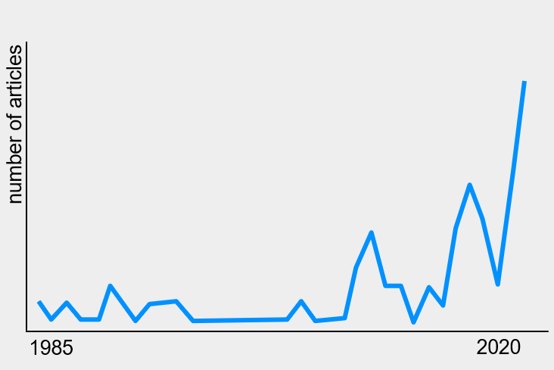
Figure 1. EM/CA studies on AI-related topics over the years.
Due to the nature and length of a scoping review report, here we can only briefly gloss the contents of the detailed empirical studies collected in our corpus. This is an especially challenging limitation for reporting on EM/CA research with its meticulous descriptions of social action with an imperative, as Garfinkel, (1991, p. 15) puts it, that “concreteness [should] not be handed over to generalities”. However, while empirical works form the centerpiece of our collected studies of situated AI technology use, here we take up Anderson and Sharrock’s recommendation to relax this imperative “to enable reflection on the really quite numerous collection which has already been generated” (2017, p. 19). One of the central aims of this review is to provide this opportunity for reflection, specifically on EM/CA studies dealing with AI, presenting our findings on the applications, overall trends, and major findings of EM/CA studies of AI. The discussion section addresses the findings from the scoping review and combines them with insights from the theoretical papers to explore how can EM/CA work contributes to various stages of technology inception, development and implementation, as well as to outline some of the prospects and limitations of this flourishing area of research. We conclude by asking what these studies offer to future social studies of AI and suggest how their outcomes remain relevant to the ongoing development of AI, its technical applications, and to its conceptualizations and roles within the social sciences more broadly.

2. Data and methods: The review procedure
Scoping reviews are an established research method (see Munn et al., 2018), but their application to studies of situated technology use comes with several methodological problems. This section describes our review process and how we addressed these issues.
To produce a coherent corpus of EM/CA research on AI, we had to establish a working understanding of both “AI” and “EM/CA”, since both have a range of possible interpretations. Our working notion of AI, in this context, included all studies in which technology fills a social role that is generally reserved for a human interactant. Examples include technology that serves as a driver, a tutor, a student, a caller/answerer of the telephone, or a chess player. Arguably, many technologies occupy roles historically undertaken by humans, for example ‘calculator’ was originally a human job title. But electronic calculators (as we understand the term today) no longer also perform conventionally human social roles and functions, which is what we are interested in for this review. The reason we do not take a more technical working notion of AI, such as ‘any technology that utilizes AI systems in their workings’, is twofold. Firstly, such a technical approach would yield an immense diversity of technologies that are difficult to compare meaningfully, including technologies that would not be considered as related to AI by ordinary users. Secondly, the functioning of a social technology relies on AI to varying degrees depending on the specific social machine, and technical systems are combined in non-interchangeable ways. For example, a scripted social robot that uses Natural Language Processing (NLP) to deal with input and Natural Language Generation (NLG) to ‘speak’ its output technically uses AI to function, but the scripted ways it conducts itself within the interaction are not necessarily driven by AI. The implementation of AI in such a machine is incomparable to a system that uses AI to drive its central functions, such as the chess system AlphaGo. Therefore, we opted for a situated approach that includes studies of systems designed to perform social roles that have only recently been filled by AI systems. Our working notion of EM/CA included all papers that self-identify as contributions to EM and/or CA, primarily to ensure a methodological coherence of the reviewed research and comparability of their findings. These studies all focus on the detailed analysis of practical action and reasoning around AI. They show how interaction with and around AI-based systems unfolds in real time by highlighting its sequential organization.
Since our target studies fell between many disparate fields and may have appeared in many different journals, conference proceedings, and (often less well-indexed) edited collections, we had to use a range of specialist bibliographies and scholarly search engines. Using our working notions of EM/CA and AI, we began our collection of relevant texts for the scoping review using the EMCA Wiki, a specialist bibliography database that has been systematically archiving metadata of publications in the field (primarily books and journal articles). It considers a textual self-identification with or stated relevance to the field as a criterion for inclusion. The database provided 77 studies that self-identify as related to or grounded in EM/CA and at the same time deal with various AI-related technologies, according to our notion of AI. To ensure that our collection is as complete and exhaustive as possible, we have also employed several academic search engines: ACM, IEEE, LLBA, Springer, and Web of Science (see Appendix A for the search strategy used). Only studies that focus on the local order of interacting with and around AI that employ the analytical orientations described above were included in our corpus. We therefore constrained our search terms to texts that mentioned ethnomethodology and/or conversation analysis in their abstract or author keywords. Five further articles were found through ‘snowball’ sampling references from the articles already collected in this way. For these articles, the main text was searched to ensure they discuss the situated approaches extensively or make explicit use of their conceptual and methodological apparatus, despite not having the approach(es) mentioned in their abstract or keyword sections.
This sequence of steps yielded 93 text units in total, published between 1985 and 2022 (22 were older than 10 years): 10 book chapters, 34 conference papers, and 49 journal articles. While the conference papers were overwhelmingly published in venues considered to be linked to the fields of HRI (29%) and HCI (48%), the journal articles were mostly published in sociological journals. Nevertheless, the reviewed studies also appeared across a diverse range of disciplinary venues such as linguistics, clinical medicine, philosophy, psychology, engineering, media, and communication. We separated the 93 texts into two categories, namely those that make a theoretical or methodological point (n = 39) and those that present empirical findings (n = 54). The following section reviews the 54 empirical studies of situated uses of AI-related technology, aiming to map trends in the field over time and keep track of topics, populations, and empirical material examined in these studies.

3. Findings
As an initial step in reviewing EM/CA studies of AI, we have conducted a qualitative inquiry into the reference lists of items collected in the corpus (see section 2), using social network analysis to identify the most salient references (Mlynář et al., 2021). This indicates that there are canonical papers that inform AI-related studies in particular, while continuing to shape the field as a whole (see Figure 2). These texts are consistently and highly cited within the fields of human interaction research, human-machine interaction, and science and technology studies, providing important entry points and defining characteristics of the approach. Sormani (2019) outlines three complementary but distinctive strands of EM/CA that can also be discerned in our literature sample: conceptual analysis, conversation analysis, and practical analysis. The most frequently cited items were: Sacks, Schegloff and Jefferson’s (1974) “turn-taking paper” (in 45% of items from the corpus), Garfinkel’s (1967) Studies in Ethnomethodology (40%), and Suchman’s (1987) book (31%). Taken as a whole, the three publications neatly represent the current variety of EM/CA, respecifying work with technology as situated action that takes place in local settings, socially organized material environments, and in real time social interaction.
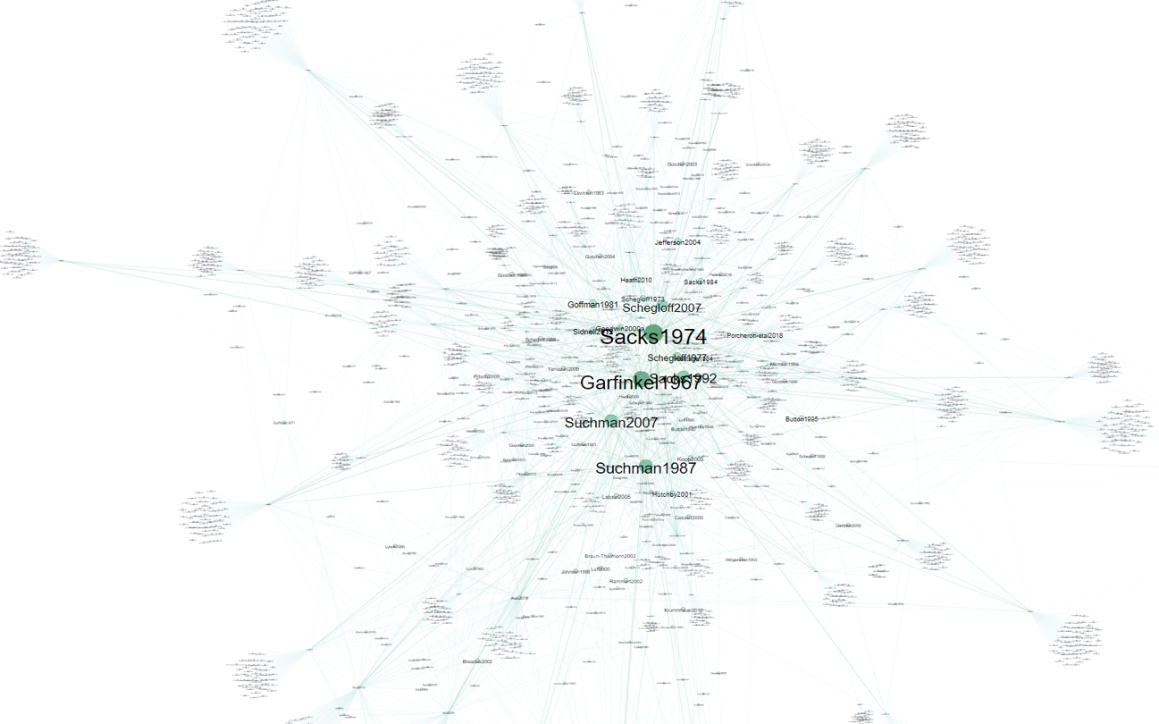
Figure 2. Citation network of references of papers from the corpus. Node size represents citation count.
Despite these common origins, networks of recent EM/CA studies of AI are more fragmented, pointing to an orientation to the specific disciplinary issues of the researched settings (e.g., medicine or education) rather than making connections to other EM/CA studies of AI through mutual referencing. As we can see in Figure 3, there are several “citation hubs”: Alač (2016), Pitsch et al. (2013), and Porcheron et al. (2018), while some other papers seem rather disconnected from these clusters. How can we account for this fragmentation? What do the texts have in common? What makes them different from each other? Having used these exploratory bibliometric networks to develop a range of such questions, we moved on to a scoping review of the methodology, subject matter, and main findings of the items in our corpus. We zeroed in on the particularities of the examined technologies, the varieties of the human participants, and the differences in presentation of empirical data, accounting for what might be behind the structures visible in Figures 2 and 3. In the following subsections we first outline the trends we identified in the kinds of technologies and the users involved in our selected studies, then provide a broader overview of the field. We then summarize the empirical findings reported across the corpus centering on three key topics: opening and closing, miscommunication, and non-vocal aspects.
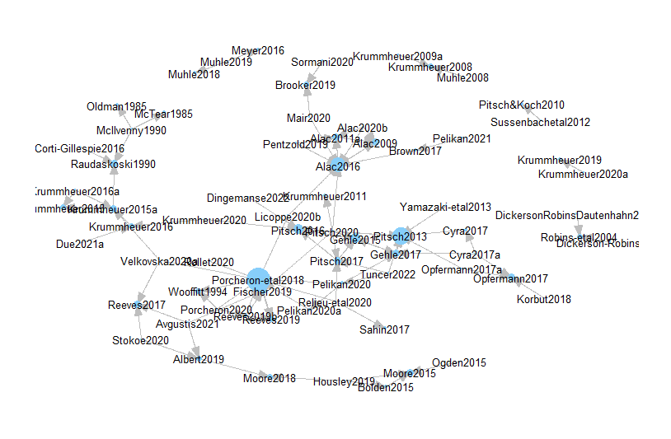Figure 3. Citation network of EM/CA papers on AI. Directed arrow indicates “cited by”.

3.1 General trends

3.1.1 Technologies studied
The 54 empirical studies we reviewed feature a wide range of technologies (see Figure 4). Robots were studied most often (n = 28) followed by Voice User Interfaces (VUI; n = 14) and Virtual Agents (VA; n = 9). One article investigated how technical agency is granted to an artifact by comparing interaction with a virtual agent (Max) to interaction with a walking aid (Krummheuer, 2015a). Overall, there is a clear tendency in our corpus towards studies of technologies that involve the use of spoken language such as VUIs, VAs and social robots.

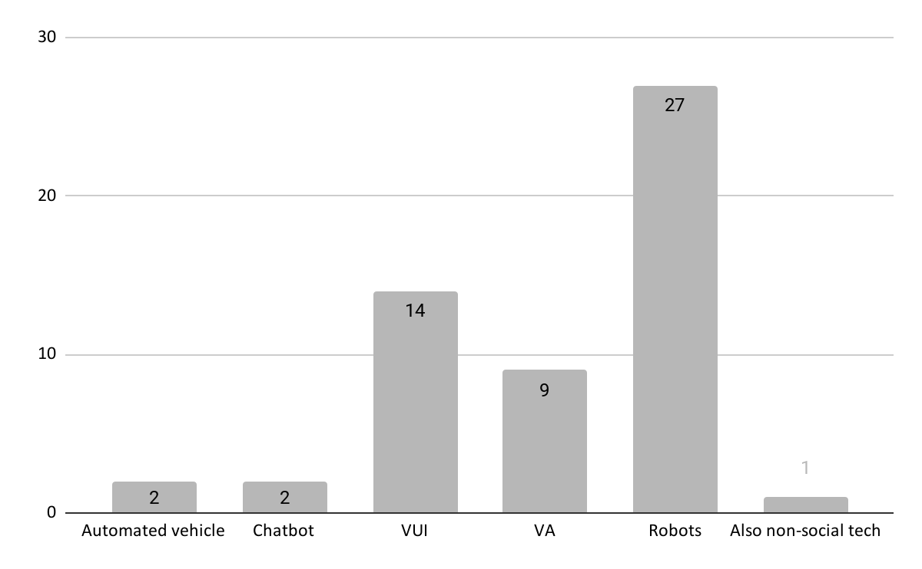
Figure 4: Technology studied in the reviewed articles.
The robots studied were mostly humanoid designs, although Muhle (2008) studied interaction with an Aibo robot dog and Pitsch and Koch (2010) presented a case study of a toddler interacting with advanced toy robot dinosaur named Pleo. In both studies, the robot was programmed to act in a way that would resemble animal-like rather than human-like behavior. By contrast, Payr (2010) reports on a study of Nabaztag, a robot bunny and home companion that was programmed to perform the role of a health coach by greeting users, asking them about their day, and suggesting health related activities like exercise or weighing themselves. Most studies featured humanoid robots including one-off studies of Lekbot, Robota, Robovie-R and BIRON (all n = 1), though some more widespread humanoid robots such as Nao (n = 6), Pepper (n = 4) and Cozmo (n = 3) appear in multiple studies. One study focused on the behavior of industrial robot arms, to which the researchers added a screen that enabled it to present the user with different gaze patterns (Fischer et al., 2015).
In the category of VUIs, two distinct types of technology are used. First, there are the smart assistants such as Alexa, Siri and Google Assistant (Alac et al., 2020; Fischer et al., 2019; Porcheron et al., 2017; Porcheron et al., 2018; Velkovska et al., 2020). Second, there are the telephone systems such as Lenny and Mystery Shopper that simulate real callers, and telephone systems that act as operators of some sort (Aranguren, 2014; Avgustis et al., 2021; Wallis, 2008; Wooffitt, 1994) or do automated interviews (Klowait, 2017).
There was also a variety of VAs (sometimes also called Embodied Conversational Agents) studied in the corpus. For example, the agent Max consisted of a cartoonlike 3D body projected onto a screen with which passersby in a shopping mall could interact using a keyboard while the agent gave verbal responses (Krummheuer, 2008, 2008a, 2009a, 2015a, 2015b; Krummheuer et al., 2020a). Two studies analyzed interactions with an agent that was somewhat similar to Max: a “Wizard of Oz” controlled agent named Billie, which also consisted of a cartoonlike body, visible on screen from the hips up, but rendered in a 2D style and able to interact with users entirely through speech (Cyra & Pitsch, 2017; Opfermann et al., 2017). Lastly, two studies used more realistic talking heads: one system controlled by a human wizard acting as a therapist for participants role-playing patients (Torre et al., 2021), and one using an autonomous system asking a series of pre-recorded diagnostic questions in a memory clinic (Walker et al., 2020).
Lastly, some studies addressed automated vehicles (n = 2) (Brown & Laurier, 2017; Pelikan, 2021) or chatbots (n = 2) (Corti & Gillespie, 2016; Jentzsch et al., 2019). While the relatively low number of automated vehicle studies could be explained by the technology only recently emerging for applications “in the wild”, it is noteworthy that there have been relatively few studies of chatbots despite these systems having existed for decades, and becoming commonplace in certain real-world contexts. Note also that some of these studies, especially those using a Wizard of Oz methodology, sometimes combined or conflated user understandings of what these technologies are capable of. For example, Jentzsch et al. (2019) used a research design that implied to users tasks requested via text chat would be performed by a physical robot, combining the (usually distinct) categories of chatbot and robot.

3.1.2 Technologies setup
In addition to the variety of technologies studied, the setup of the technologies varied. The vast majority of studies addressed autonomous systems (n = 45) (see Figure 5). Within this category we counted all technology that was not manually controlled during the interaction. Note however, that these autonomous systems had widely varying levels of interactional competence. Some could only speak pre-recorded lines (e.g., Walker et al., 2020), or perform a very basic script (e.g., Licoppe & Rollet, 2020), or some mixture of both (e.g., Sahin et al., 2017; Relieu et al., 2020). Of these autonomous systems, 23 were robots, 13 were VUIs, 6 were VAs, two were automated vehicles, and one was a chatbot.
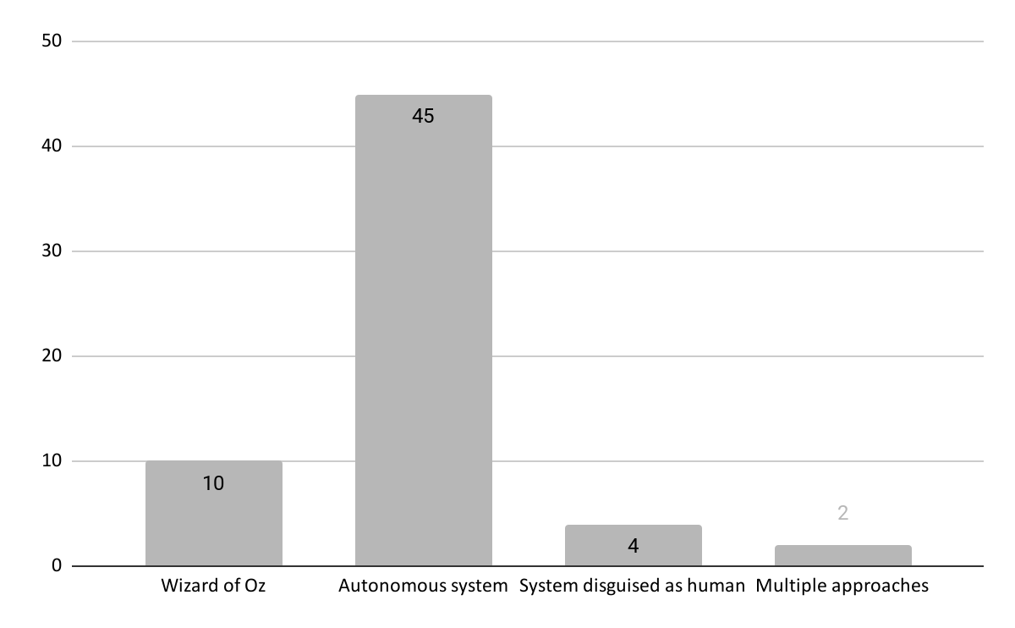
Aside from autonomous systems, a Wizard of Oz setup, was also used in 9 studies (5 robots, 3 VAs, 1 VUI, 1 chatbot). Although this type of setup is in some ways similar to teleoperated technologies, we chose to include these texts on the basis that Wizard of Oz is a common technique used in the broader field of HCI to emulate human-like interactional roles and competences. In the following sections, we will point out some common tendencies in the Wizard of Oz-based studies to indicate how including these articles might have affected the overall trends we have found.
Figure 5. Setup of the technology discussed in the reviewed articles. Note: All systems disguised as human were autonomous and are counted as such.
Some studies also used computer systems that were presented to the user as human. Two studies used the Lenny system (Relieu et al., 2020; Sahin et al., 2017), a voice chatbot that can be used against unwanted callers such as telemarketers or scam calls. By playing pre-recorded lines when the caller is silent, this system is designed to create the impression that the caller is speaking to a human being. Another study used simulated calls to veterinary clinics (Stokoe et al., 2020), focusing on the simulated role of the caller rather than the call-taker. Lastly, one study used multiple approaches to explore the differences between a call-taker expecting to be talking to a human and when they are expecting to be talking to an automated system, and comparing interaction via chat to face-to-face interaction. This study had participants interact with chatbots in four different conditions: chat vs. face-to-face and informed vs. uninformed that they would be interacting with a machine (Corti & Gillespie, 2016).
Our sample showed the diversity of technologies studied, and the following trends within the field: robots are studied most frequently, and most studies focused on autonomously operating (rather than manually operated) systems. Next, we explore some emerging patterns in the characteristics of the human participants interacting with these technological systems.

3.1.3 Settings, participants and activities
Aside from the technology used, there was also variation amongst the human interlocutors studied with regard to age (e.g., studying a specific age group such as toddlers, students or elderly) (see Figure 6), languages spoken (see Figure 7), and other factors (e.g., adult-child constellations, people with cognitive disorders, data collection in a public setting) (see Table 1). The activity participants were engaged in with the technology varied as well, from tutoring a robot to perform a simple task, playing a game with or through the technology, being coached by technology, encountering the technology in a daily activity (e.g., shopping mall) to routine use of already-owned technologies (e.g., querying Alexa) (see Appendix B for activities and a non-aggregated overview of all articles).
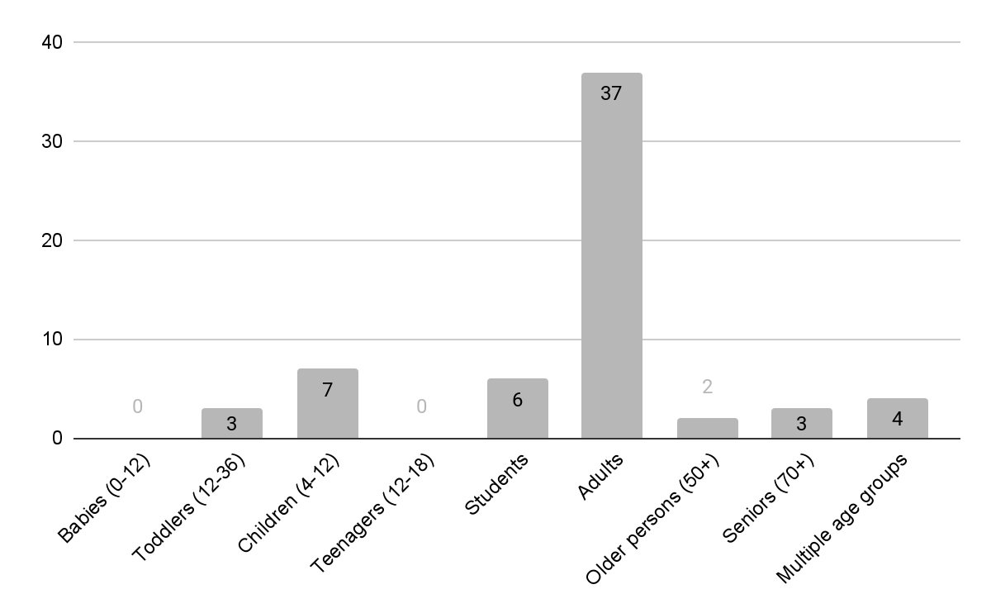
Figure 6. Participant age groups in the reviewed papers. Note: “Adults” generally means that age group was not specified.
Studies rarely addressed a specific age group, in which case it was assumed participants were adults of varying ages (n = 37). There were also studies of very young users such as toddlers (n = 3) and children (n = 7), though none featuring teenagers. Some studies mentioned participant groups consisting of students (n = 6), and one study used students as a control group while focusing on seniors (Cyra & Pitsch, 2017). Some studies addressed persons of 50 years and older (n = 2) and seniors of 70 years and older (n = 3). Lastly, a few studies specifically addressed multiple age groups (n = 4). Studies were only included in this category when the age groups were interacting with the technology separately, for example excluding studies concerned with adult-child constellations.
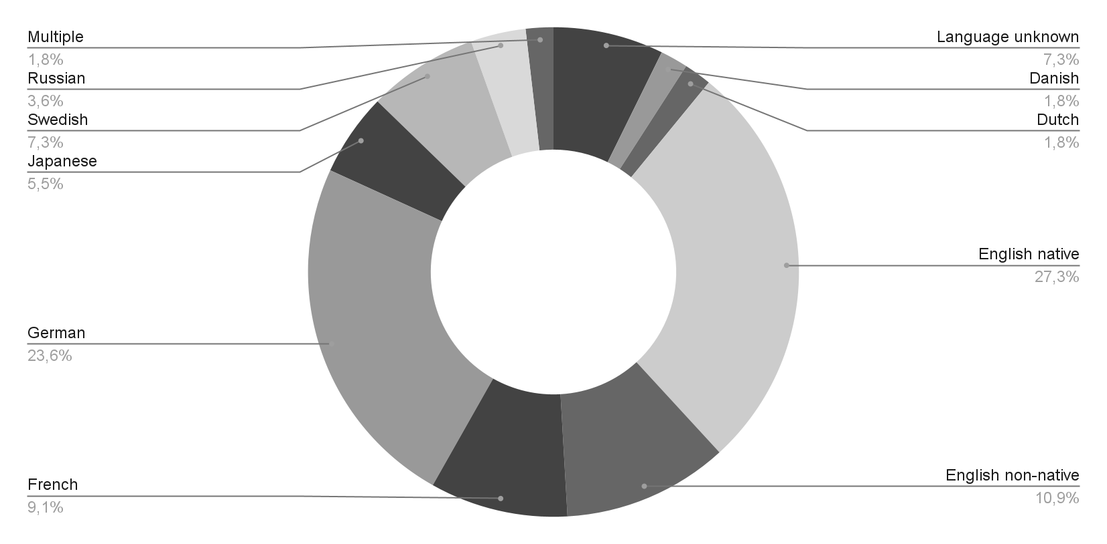
Figure 7. Languages spoken by the participants in the reviewed papers. Note: ‘English native’ consists of studies in the UK (n = 11), US (n = 4) and Ireland (n = 1, a study that also used UK data).
The languages spoken by participants also varied, although English was predominant (n = 21, 14 native speakers , 5 non-native, and 1 both), with British English being the most common variant (n = 11). Another common language was German (n = 13), followed by French (n = 5) Swedish (n = 4, one of which also used German data) and Japanese (n = 3). In some studies the language was not specified nor discerned due to the focus on non-vocal interaction (n = 4). Other languages were Russian (n = 2), Danish (n = 1), and Dutch (n = 1), and one study looked at children from all over the world who recently moved to Sweden (Tuncer et al., 2022).
Table 1. Additional features of settings and participants in the reviewed papers.
Public space (e.g., museum, school, shopping mall) | 18
Real-world telephone calls | 6
Adult-child constellations (e.g., households, teacher-child, researcher-child) | 10
Households (e.g., couples, families, dormitories) | 6
Researchers are part of the interaction | 4
(Mild) cognitive impaired people (e.g., dementia, Acquired Brain Injury, Autism, Cerebral Palsy) | 7
No specific additional aspect | 15
Note. ‘Adult-child constellations’ overlaps 4 times with ‘Households’ and 2 times with “Researchers are part of the interaction”.
Lastly, there were some trends in the dataset regarding specific settings or participant groups. Many studies concerned data collected in a public space, such as a museum, school hallway or shopping mall (n = 18) or used real-world telephone calls (n = 6). This is in line with the situated approach of ethnomethodology and conversation analysis, which generally takes naturally-occurring social interaction as its empirical material. Furthermore, some studies specifically focused on interactions in which one or more children interacted with technology together with (an) adult(s). In one case, this adult was the researcher who was present to ensure the toddler would not break the robot but who also interacted with the child and the robot (Pitsch & Koch, 2010), but generally the adult was a guardian or teacher. The adult-child category overlaps 4 times with studies looking at interaction between households (couples, dormitories, families) and technology (n = 6). Households also offer opportunities to study the technology in its ‘natural’ or designed-for habitat. By contrast, some studies had a researcher present during the interaction (n = 4), which is arguably less natural. However, these studies all reported on how the researcher was involved in the interactional setting. Lastly, some studies had participants with specific cognitive impairments, such as (mild) dementia, Acquired Brain Injury, Autism or Cerebral Palsy (n = 7). In the Wizard of Oz studies in our sample (n = 10), there were no clear trends in the terms of the kind of technology used (5 robots, 3 VAs, 1 VUI, 1 chatbot), nor in participant categories (8 adult/non-specified, 2 senior; 8 no additional features, 2 (mild) cognitive impairments).

3.2 Interactional phenomena
There were clear trends in the focal interactional phenomena explored by the studies in our corpus (see Table 1) with the three key topics being: 1) how interactions are opened and closed; 2) miscommunication and how it is resolved (i.e., conversational repair); and 3) non-vocal communication and emotion displays.
Table 2. Overview of the key topics in the empirical articles.
Key topic adressed | Main topic (N = 54) | Touches on (N = 54)
Opening and closing interaction | 6 (~11%) | 5
Miscommunication and repair | 14 (~26%) | 5
Non-vocal communication and emotion displays | 16 (~30%)  (of which 3 on emotion) | 0

3.2.1 Opening and closing interaction
The studies in our corpus recurrently deal with openings and closings in interactions with AI (6 out of 54, and a section in the analysis of 5 more papers). These include openings and closings with robots (n = 7) and telephone systems (n = 3). Most studies focus on openings with only two papers addressing how interactions are closed (Licoppe & Rollet, 2020; Payr, 2010). In the following section we outline how EM/CA studies of AI treat this foundational interactional phenomenon (see e.g., Schegloff, 1968; Schegloff & Sacks, 1973).
Establishing mutual recognition and accessibility is core to opening an interaction, and is usually accomplished through a multitude of vocal and non-vocal resources (e.g., see Kendon, 1990). In human-robot interaction (HRI), participants accomplish multimodal openings with gaze playing a similarly important role as in human interactional openings (Gehle et al., 2017; Pitsch et al., 2009). For example, a robot that restarts its sentence when it loses the addressee's gaze is more successful in getting their attention and thus opening interaction (Pitsch et al., 2009). Similarly, Iwasaki et al. (2019) used a combination of field and laboratory experiments to show how a robot that returns a prospective users’ gaze during a greeting-and-opening sequence receives responses much more often than if it uses only verbalized greetings (e.g., ‘May I help you?’). They also suggest that people’s initial impressions and expectations of a robot’s perceptual capabilities significantly change their behavior towards the robot and influence whether they will engage in a two-way interaction with it. Süssenbach et al., (2012) make a similar observation in their case study exploring pre-opening interactional activities such as how a robot is presented to a naïve user by someone familiar with the system. They showing that the user’s initial expectations are strongly influenced by how the robot is first introduced. Both studies suggest that the initial framing of the robot and its abilities to display interactional gaze practices are an important resource in opening an interaction.
For telephone-based systems such as Lenny (Sahin et al., 2017), other kinds of paralinguistic resources such as hesitations, disfluencies and other troubles of speaking are particularly important for creating this strong first impression during openings. Lenny is intended to ‘trap’ unsolicited spam, hoax, and telemarketer callers by engaging them in conversation with an automated agent. Despite using only pre-recorded turns, Lenny is remarkably successful at keeping this facade up as long as possible (average call times are just under 10 minutes), which Sahin and colleagues (2017) suggest comes from Lenny’s openings displaying intial availability and willingness to talk, then complicating the interaction immediately by displaying troubles of speaking and hearing which are unrelated to the willingness, yet take time to resolve. In all these cases, the interactional goals and first impressions of the human interacting with the technology seems to strongly inform the success of the interactional opening in initiating (and then maintaining) ongoing interaction.
Across our corpus of studies, closings in interactions with robots are accomplished in a variety of ways, one of which is leaving the interaction without closing at all, i.e., walking away without any preparatory interactional work or even mutually acknowledging that the interaction has ended (e.g., Licoppe & Rollet, 2020; Payr, 2010). When closings are described, they involve multiple strategies such as the inclusion of pre-closing or closing-implicative moves (e.g., “okay”, see also Schegloff & Sacks, 1973) and/or providing an account (e.g., “I have to go”, Licoppe & Rollet, 2020). Humans also seem to make pre-closing moves without leaving room for the robot to respond, suggesting ambivalence towards treating the robot as an ‘official’ interlocutor; a (pre-)closing sequence orients towards collaboratively closing the interaction, whereas denying the robot an opportunity to (dis)align with the closing does not (Licoppe & Rollet, 2020). Reported closing behaviors with robots also change over time (as in human interaction, cf. Berger & Pekarek Doehler, 2018). When mapping the closings of one participant over ten days, Payr (2010) found the participant ending the interaction through both vocal and non-vocal closing moves, waiting for the robot to close, and leaving without closing. While still performing closings, leaving without closings became more frequent over the ten days (Payr, 2010). Payr (2010) also points out that the participant orients to social norms in her closings (e.g., providing justification for closing the interaction at this point) and that instances in which the participant leaves without closing looks more like turning off a machine (p. 480). So, how closings are done in HRI is tied to their status in the interaction, i.e., being treated (more) as interactional partner or (more) as an object.
Notably, the papers on closings discuss how the AI-based system is, in many cases, disregarded as a social entity when, for example, users leave abruptly without providing an account or even uttering a word in closing. Conversely, the papers concerning openings mostly address how a robot can get the user’s attention in the first place, providing findings and suggestions as to what makes certain behavior work (e.g., Gehle et al., 2017; Iwasaki et al., 2019; Pitsch et al., 2009; Sahin et al., 2017). On the one hand, this offers some key insights into common issues for HRI, e.g., that establishing mutual attention is not a given for these technological systems but requires specific perceptual and behavioral design as well as other technical and aesthetic design choices. This is especially true for robots which, despite drawing attention or curiosity apparently by virtue of their appearance as robots, are not easily able to communicate their availability for interaction. On the other hand, users tend to close interaction with a robot in a variety of ways, sometimes without orienting to the system as a social entity (Licoppe & Rollet, 2020). While closings are only studied in two of the papers in our corpus, their findings suggest that robots potentially struggle to sustain displays of sociality until the end of an interaction. This “problem of closings” (Schegloff & Sacks, 1973: 292) may relate to some of the many issues of miscommunication in human-AI interaction documented in our corpus of EM/CA studies.

3.2.2 Miscommunication
Miscommunication is another recurring topic in our dataset (14 out of 54, and a section in the analysis of 5 more papers). Of course, miscommunication is a pervasive concern for all participants in social interaction (see Jefferson, 2018), which may partly explain why so many papers in our corpus take this as a focus of study. Since the reviewed studies take a fundamentally inductive approach that draws topics from their data (see Sacks, 1984), the prominence of this topic may also be due to the inability of many social-technological systems to sustain social interaction without frequent and unresolved miscommunication.
Some studies focused on the possibility of (automatically) identifying moments of miscommunication (a significant practical issue since to be analyzed and resolved, such moments first need to be identified). One paper used swearing to find moments of trouble (Wallis, 2008), another characterized a prototypical script then used deviations from the script as an indicator of miscommunication (Lohse et al., 2009). Krummheuer (2008) focused on how displays of misunderstanding are done in interaction between humans and an Embodied Conversational Agent. Others focused on how humans adapt to interaction with an AI system over time by exploring moments of miscommunication (e.g., Licoppe & Rollet, 2020; Pelikan & Broth, 2016; Stommel et al., 2022). For example, a user may first orient to human social norms for timing their responses but, when this leads trouble, (e.g., the robot continuing its turn and thus overlapping with the user), users will adapt their turn-taking behavior by, among other things, leaving longer gaps before responding (Pelikan & Broth, 2016). Trouble may also escalate, with users first addressing the trouble by repeating or rephrasing their turn but, when this fails, using more extreme strategies such as resorting to scripted commands (e.g., ‘skip’) or changing their answer in a way that advances the robot’s script (Stommel et al., 2022). Similarly when facing complex interactional trouble, users of VUIs tend to prioritize restoring the progressivity of the interaction, rather than resolving the miscommunication (Fischer et al., 2019), which follows the broader preference for progressivity in many forms of human interaction more broadly (see Stivers & Robinson, 2006; Heritage, 2007). Lastly, in some cases humans do not appear to adapt to misbehaving technology even when they are experienced and well-informed about it. Pelikan (2021) described how an automated shuttle bus on public roads in Sweden was programmed to apply emergency brakes whenever it encountered a situation it could not handle such as being overtaken by other road users. However, even after the bus had been on the road for nine months with a sign on the back warning drivers to keep their distance to avoid triggering the emergency brakes, road users continued to maneuver around the bus, rendering it a static obstacle for other road users.
Miscommunication is also sometimes related to a mismatch between user expectations and system capabilities (e.g., Arend et al., 2017; Muhle, 2008; Pelikan & Broth, 2016). For example, Corti & Gillespie (2016) found that humans handle miscommunication differently when they are told that they will be communicating with a chatbot rather than a (presumed) human interactant even without knowledge of the chatbot’s affordances. Similarly, when using a self-driving vehicle, users learn the system’s limitations and adjust their own behavior by monitoring the road during autopilot driving, then control in situations that they have learned the system struggles with (Brown & Laurier, 2017). In order to learn more about the system users also turn to system-external resources when available, such as a manual or a co-present expert such as the researcher or designer (see Alač et al., 2011; Arend et al., 2017; Muhle, 2008). Muhle (2008) notes that this often entails the system being occasionally “degraded” from co-participant to topic, while users try to figure out how to continue in interacting with the machine. Süssenbach and colleagues (2012) show that users assess the system’s competencies step-by-step and that they differentiate between the robot’s role as a social actor and the robot’s role in that specific interaction (in their case, a fitness instructor). They also point out that how a system is set up and introduced before the interaction influences how it is understood and treated by the user in that moment (Süssenbach et al., 2012, p. 1124), similarly to studies of the phone chatbot“Lenny” mentioned above.
With regard to the type of trouble occurring, there can be multiple issues. Firstly, the machine can have trouble hearing (and/or transcribing) the user’s voice input correctly or at all. Secondly, the machine may ‘hear’ but then fail to recognize and correctly interpret the input. Several articles found that when trouble occurs, users tend to treat this as a problem of hearing, despite the system not specifying the cause of the problem (e.g., Avgustis et al., 2021; Stommel et al., 2022). One suggestion for improving design for miscommunication is to provide the user with more relevant feedback on the nature of the problem (e.g., Porcheron et al., 2017; and see also CA research on repair, e.g., Schegloff, 1992; Drew, 1997).
Suchman’s (1987) foundational work on human-machine interaction first pointed out that that despite rapid technological advancements, certain issues remain fundamentally unresolved even after several decades of significant progress and innovation. In this vein, a key issue of miscommunication that many papers touch on is that the system often lacks access to the same information as the human and vice versa. These technical, perceptual, and design issues can range from sensors being unable to function in certain conditions that would yield no trouble for a human actor (e.g., sunlight preventing the autopilot from making the correct move, Brown & Laurier, 2017) to sensors being (temporarily) shut off or not present at all (e.g., certain robots stop ‘listening’ when producing their turn so they don’t get confused by their own audio, e.g., Pelikan & Broth, 2016; Stommel et al., 2022).

3.2.3 Non-vocal conduct and emotion
Across our data set, there is a key distinction between articles that focus on human non-vocal conduct or emotion displays versus those that focus on robot non-vocal conduct or emotion displays. The former focuses on what humans do, either as something that could be used to improve robot design (e.g., showing that a robot that waits until a human is looking at it before opening an interaction is more successful at securing human attention, Pitsch et al., 2009), or how human non-vocal conduct is done during HRI (e.g., gaze and smile patterns between unacquainted children when interacting with a robot, Tuncer et al., 2022). The latter focuses on robot non-vocal behaviors and humans’ interactional responses [citation needed]. In the following section, we discuss these papers for the sake of topical coherence, although we note here that these two approaches carry quite different theoretical, design, and analytic implications. In any case, non-vocal conduct and emotion displays were common topics in the dataset (n = 16, of which 3 focused on emotion). We discuss these topics together because emotion displays often involve non-vocal cues. Studies of non-vocal conduct described the use of interactional resources including gaze (Fischer et al., 2015; Gehle et al., 2017; Iwasaki et al., 2019; Pitsch et al., 2009, 2013; Tuncer et al., 2022), gesture (at least mentioned by e.g., Arend et al., 2017; Pelikan & Broth, 2016), smiling (Torre et al., 2021; Tuncer et al., 2022), mobile interaction (Brown & Laurier, 2017; Pelikan, 2021), body posture/position (Alač et al., 2011), touch (e.g., how is the robot handled, Alač, 2016; petting of the robot, Pelikan et al., 2020), and bodily presence (Corti & Gillespie, 2016).
Most studies find that users tend to draw on their repertoire of practices from non-vocal human-human interaction when learning to interact with social technology. For example, the way that gaze functions as a resource for managing availability for interaction in both human-human and human-AI openings holds true for many other interactional practices. Similarly, Fischer et al. (2015) report on an industrial robot arm that utilizes ‘social gaze’ by gazing at its human tutor only when ready for instruction and gazing at the object it was manipulating while still performing the task. The fact that the robot using social gaze was able to solicit additional instructions from users more quickly than when it used random gaze patterns, along with related studies of gaze in interactional openings (Pitsch, 2009), suggests that gaze and gaze timing are a critical non-vocal interactional resources for managing mutual attention (Fischer et al., 2015). A related study by Pitsch et al. (2013) found that human tutors adjust the way they present instructions (e.g., pace of talk, pauses) depending on the robot’s gaze behavior, suggesting that optimizing gaze strategies for specific HRI instructional tasks could elicit more useful user input and more compliant robot behaviour.
The importance of the precise timing of embodied actions was also an important finding for a range of non-vocal conduct. An experiment by Torre et al. (2021) uses a virtual head with four different smiling conditions to show that humans do no, as some studies suggest, simply mimic the smile behaviors and timing displayed by a VA. Instead, at smile-relevant moments in an interaction, human users smile in an affiliative way when the VA also produces a smile, and in a disafilliative way if the VA fails to smile at the appropriate time. Similarly, Pelikan et al. (2020) found that ‘happy’ and ‘sad’ emotion displays by a Cozmo robot were treated as a response to the immediately preceding actions and that a ‘happy’ display had a different contingent effect on the ongoing interaction than the ‘sad’ display. They found that after a ‘happy’ display the interaction tends to proceed, while ‘sad’ displays function as a sort of repair initiation or “rewind button”, where the user’s subsequent talk treats the display as an indication that something that needs to be ‘fixed’ before the interaction can proceed (Pelikan et al., 2020).
Gaze and smiling are also discussed together. For example, Fischer and colleagues (2015) noted that users smiled more often in the interaction where the robot used social gaze (looking at the user when ready for instructions), and users generally smiled at these moments when gaze with the robot was re-established. One article also showed how robot behavior can facilitate mutual gaze and smiling between (unacquainted) children (Torre et al., 2021), showing how the non-vocal behavior of users can be mediated by robot facilitation. These studies all point out that smiling and emotion displays by humans should be analyzed as performing a social function rather than interpreted as a reflection of emotional states as such.
Human-human interaction often involves non-vocal practices for coordinating entry into and exit from social interaction (Pillet-Shore, 2010; De Stefani & Mondada, 2018) and the studies in our corpus show that the same is true for human-AI interaction. Alač et al. (2011) show how toddlers treat a robot as a social actor by gazing and turning their bodies towards it. The relevance of embodied resources and bodily presence for interaction is further reinforced in a study by Corti and Gillespie (2016) showing that participants are more likely to initiate repair and deal with miscommunication when they assume they are speaking with a co-present human. Participants made less effort to repair miscommunication when informed that they were a) speaking to a human actor voicing an AI’s responses or b) that they were communicating with an AI via text chat. Though it is not specifically about non-vocal communication, this study reemphasizes the importance of the body for human-AI interaction for reinforcing participants’ presuppositions that they are interacting with another human.
Road traffic is another interactional context in which communication is mostly non-vocal, and where mutual understanding is critical. A range of studies show that understanding the intentions of other road users is still difficult for automated vehicles (Brown & Laurier, 2017; Pelikan, 2021). For instance, speeding and slowing down are important indicators for the actions a traffic user is about to take (and, implicitly, for demonstrating their perception of the situation), which can lead to trouble when an automated vehicle does not use and/or is not sensitive to these kinds of social signals (Pelikan, 2021). This can be an impediment to the smooth performance of even the most routine traffic manouvres, such as overtaking (Pelikan, 2021).
Overall, these studies highlight the interactional contingencies of non-vocal and emotional communication and extended existing findings from EM/CA research that show how emotion cannot be simplified into categories such as ‘smiling is happy’ (Perakyla & Sorjonen, 2012) or ‘one needs to gaze at someone else at all times’. Across our data set, the timing of these moves and their preceding actions seem to be crucial to how the interaction unfolds. Gaze plays an especially large role in facilitating social interaction, from opening and closing the interaction, to providing insight into the machine’s functioning and how to interact with it.

4. Discussion: The relationship between technology and studies of situated action
This review has aimed to demonstrate and explicate the specific contribution of EM/CA and studies of situated action and AI-based technology to the broader field of social studies of AI. So far, we have presented the main features of the corpus of empirical (rather than theoretical) studies featured in our scoping review. In the following section, we make reference to the theoretical and methodological literature in EM/CA studies of AI (and technology more generally) to discuss the implications of the reported findings, focusing on their contribution to the cycle of technology conceptualization, design, evaluation, and implementation. We also discuss the potential for future directions of study in this field and some of its inherent limitations, as well as the limitations and possible extensions of the present scoping review.

4.1 Practical applications of EM/CA studies to technologies
Technology development and adoption can be described as a succession of several steps: inception, design, evaluation and integration (see Figure 8). First, we propose that technology is thought out and imagined “on paper” in the inception stage, producing a concept of the technology. Second, in the design stage, the technology is worked out and produced as a tangible object, leading to a technological prototype. Third, the technology is tested out and refined as a manufacturable article in the evaluation stage, with the product as its final outcome. Fourth, we propose to distinguish an integration stage, in which the technology is introduced to the general public and becomes gradually incorporated in society as routinized usage of the technology. In this section, we use this structure to summarize the main findings of our literature review and position them in the broader context of literature on AI-based technologies, demonstrating the distinctive impact of EM/CA work at all the stages of the technology development and adoption cycle.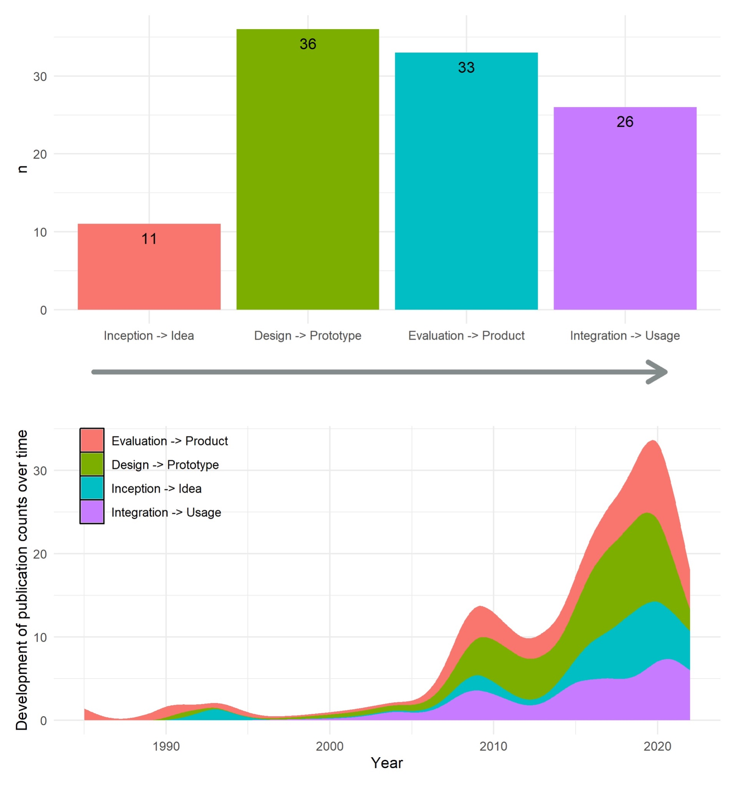Figure 8. Four steps in the lifecycle of technology development and adoption: 1. Inception and idea, 2. Design and prototyping, 3. Evaluation and improvement cycles, 4. Integration in society. A: Publication counts on each of the four stages. B: Development of publication counts over time (1985–2022).

In the inception phase of technology development and adoption, EM/CA is employed for a “respecification” (Garfinkel, 1991) of established topics of engineering and computational science, by way of conceptual analysis inspired by authors such as Ryle and Wittgenstein (e.g., Reeves, 2017; Brooker et al., 2019; Sormani, 2020; Mair et al., 2021). Another recurrent topic that can have implications at this stage is the question of agency of AI-based technologies (Pelikan et al. 2022). Are they treated by human participants as social agents, or rather as material objects (Alač, 2016; Gehle, 2017)? What are the related interactional procedures such as (tacitly or explicitly) categorizing participants as either human or AI? In a parallel vein, Brooker et al. (2019) focus on the misattribution of human capacities to machines also argue for placing “AI in its practical contexts” in order not to avoid the misleading appearance of “ghosts in the machines”.
In the design phase of technology development and adoption, EM/CA contributes to “implications for design”, as well as applied recommendations for technical solutions at the prototype level. Some of these recommendations are specific to the technology and context of each particular study (Wallis, 2008; Opfermann & Pitsch, 2017; Pelikan & Broth, 2016), while others provide more generalized suggestions that make use of EM/CA’s inherent resistance to any reification of meaning (see also Garfinkel & Sacks, 1970), instead adopting a conception of meaning as interactionally and dynamically produced moment by moment (Pelikan et al. 2020; Krummheuer, 2016; Gehle et al., 2017). Nevertheless, the question remains – as Rollet and Clavel (2020) conclude –, how to efficiently formalize the situated particulars of interaction sequences as “information” that the machines can process.
The third phase is the evaluation of existing technologies, which takes place in semi-experimental or experimental settings. EM/CA studies may focus on the question of whether the machine can constitute an interactional partner and to what extent the human and non-human participants are treated equally (Arend et al. 2017; Licoppe & Rollet 2020). In some contexts, such as medical diagnosis, a certain “rigidity” of the technological implementation can be seen as an advantage, since consistency in e.g., question design and performance might elicit more comparable answers for a coherent automation and evaluation of the processes. Avgustis et al. (2021) also propose that for some conversational agents used in service phone calls, having a more robot-like agent would reduce unmet user expectations and produce more fluent interactions, suggesting it is not always desirable to emulate human-like conduct.
EM/CA studies can also contribute at the integration level of technology implementation. As technology becomes part of everyday life, one can move beyond the pre-defined experimental goals of a study to discover previously unimaginable phenomena in the data (Tuncer et al., 2022). Pelikan (2021), for instance, points out that in the case of autonomous vehicles, coordination is often studied in experimentally restricted structured environments such as intersections. However, subtle coordination happens even in mundane activities such as overtaking, and here autonomous vehicles often struggle (see also Brown & Laurier, 2017). Research in naturalistic settings also discovers new types of “user work”, such as coordinating multiple conversational agents in a household, and the asymmetry of their use within families may disrupt or reorganize established interactional practices (Velkovska et al., 2020).

4.2 Opportunities and constraints
The group of studies reviewed in this article represent a human-centered approach to the social impact of AI at the minute level of interactional detail. This focus invites criticisms previously levelled at EM/CA more broadly: that it is programmatically disinterested in generalization (in this case, e.g., across divergent technological systems, use groups, or usage scenarios), and/or unable to address contextual or social factors that occur outside of an instance of interaction (e.g., Billig, 1999). But where these criticisms, many of which have been vigorously rebutted (e.g., Schegloff, 1999) do accurately characterize EM/CA’s theoretical and analytic parsimony (e.g., Enfield & Sidnell, 2017), this is often very useful in the context of theory-and experiment-driven HCI and HRI. The principles and methodological procedures of EM/CA tend to lead away from theorizing, from offering universally generalizable explanations, and prioritize empirical grounding over more abstract findings. They also tend to prioritize ecological validity by studying interaction in-situ, and relying on evidence drawn from the participants’ own displays of understanding. As Ziewitz (2017) aptly puts it, rather than offering “generalizable” principles, the goal of EM/CA studies is to offer transferrable findings and “observations recognizable in other empirical settings”, which can provide essential insights for systems design.
Finally, we suggest two prominent areas for future EM/CA research arising from our scoping review: 1) feeding back findings from studies of AI and situated action back into EM/CA’s ‘core’ insights into human sociality; 2) a turn to EM/CA studies of technologies that are less self-evidently amenable to interaction-analytic methods. Firstly, most of the studies reviewed here are written for an HCI and technology audience rather than aiming to advance basic research in EM/CA’s core fields of human sociality, language and interaction. This has led to a conspicuous lack of empirical studies of the very “autonomousness” or “artificialness” of AI technology: just what makes AI-powered devices what they are? When collecting the corpus of studies for this paper, this became the increasingly glaring omission in the field, which we resolved, unfortunately, by adopting a narrow working notion of AI. With a more fully developed set of empirical EM/CA studies on this fundamental topic, we would have a principled basis on which to review a more heterogeneous set of studies.
Secondly, our scoping review found that robots and VUIs receive much more attention than other AI-based devices and systems. This might be because these technologies are regarded as closer to face-to-face interaction, and therefore available for study existing methods, theories, and conceptual frameworks. Indeed, much of the work reviewed in this paper comprises the application of concepts and findings from EM/CA studies of human-human interaction to the realm of interacting with “autonomous” or “intelligent” machines. We recognize and encourage the development of EM/CA studies of AI focused more explicitly on problems, topics, and practices specific to interactions with such machines, detailing the mundane procedures by which a technology “is made at home in the world that has whatever organization it already has” (Sacks, 1992, p. 549).

5. Conclusion
This scoping review has showcased the versatility of an EM/CA approach to the study of interaction with AI. This approach has been applied to a wide range of technologies, user groups, and worksites over the last few decades. The findings produced by these studies have highlighted and provided empirical backing for the importance of exploring locally established methods of reasoning through interaction with and around AI, rather than focusing on specific modalities or design features. These EM/CA studies highlight the interactional resources and methods people use for establishing and maintaining social order in their encounters with AI, and the constitutive particularity of diverse social settings and activities. Here we have provided an initial mapping of current trends, gaps in the EM/CA literature on human-AI interaction. We have also highlighted some productive avenues for future social research, and suggested how an EM/CA approach is well-placed to study the integration of AI technologies into ever more settings, processes, and aspects of our professional activities and everyday social lives.

Bibliography
Alač, M. (2016). Social robots: Things or agents? AI & Society, 31(4), 519–535. https://doi.org/10.1007/s00146-015-0631-6
Alač, M., Gluzman, Y., Aflatoun, T., Bari, A., Jing, B., & Mozqueda, G. (2020). Talking to a Toaster: How Everyday Interactions with Digital Voice Assistants Resist a Return to the Individual. Evental Aesthetics, 9(1), 3–53.
Alač, M., Movellan, J., & Tanaka, F. (2011). When a robot is social: Spatial arrangements and multimodal semiotic engagement in the practice of social robotics. Social Studies of Science, 41(6), 893–926. https://doi.org/10.1177/0306312711420565
Anderson, R. J., & Sharrock, W. (2017). Has ethnomethodology run its course? Unpublished paper, available online: https://www.sharrockandanderson.co.uk/wp-content/uploads/2019/10/Run-its-Course-VII.pdf (Accessed 25. 1. 2023)
Aranguren, M. (2014). Le travail émotionnel du client: La structure séquentielle des émotions dans les usages problématiques d'un serveur vocal. Social Science Information, 53(3), 311–340.
Arend, B., Sunnen, P., & Caire, P. (2017). Investigating Breakdowns in Human Robot Interaction: A Conversation Analysis Guided Single Case Study of a Human-NAO Communication in a Museum Environment. International Journal of Mechanical, Aerospace, Industrial, Mechatronic and Manufacturing Engineering, 11(5), 839–845.
Avgustis, I., Shirokov, A., & Iivari, N. (2021). “Please Connect Me to a Specialist”: Scrutinising ‘Recipient Design’in Interaction with an Artificial Conversational Agent. IFIP Conference on Human-Computer Interaction, 155–176.
Berger, E., & Pekarek Doehler, S. (2018). Tracking change over time in storytelling practices: A longitudinal study of second language talk-in-interaction. In Longitudinal studies on the organization of social interaction (pp. 67–102). Springer.
Billig, M. (1999). Whose Terms? Whose Ordinariness? Rhetoric and Ideology in Conversation Analysis. Discourse & Society, 10(4), 543–558. https://doi.org/10.1177/0957926599010004005
Brooker, P., Dutton, W., & Mair, M. (2019). The new ghosts in the machine: 'Pragmatist' AI and the conceptual perils of anthropomorphic description. Ethnographic Studies, 16, 272–298.
Brown, B., & Laurier, E. (2017). The trouble with autopilots: Assisted and autonomous driving on the social road. Proceedings of the 2017 CHI Conference on Human Factors in Computing Systems, 416–429.
Button, G. (1990). Going Up a Blind Alley: Conflating Conversation Analysis and Computational Modelling. In P. Luff, N. Gilbert, & D. Frohlich (Eds.), Computers and Conversation (pp. 67–90). Academic Press. https://doi.org/10.1016/B978-0-08-050264-9.50009-9
Button, G., Coulter, J., Lee, J. R. E., & Sharrock, W. (Eds.). (1995). Computers, minds, and conduct. Polity Press ; Basil Blackwell [distributor].
Collins, H. (2018). Artifictional Intelligence: Against Humanity’s Surrender to Computers. Polity Press.
Corti, K., & Gillespie, A. (2016). Co-constructing intersubjectivity with artificial conversational agents: People are more likely to initiate repairs of misunderstandings with agents represented as human. Computers in Human Behavior, 58, 431–442. https://doi.org/10.1016/j.chb.2015.12.039
Coulter, J. (2008). Twenty-five theses against Cognitivism. Theory, Culture and Society, 25(2), 19–32.
Cyra, K., & Pitsch, K. (2017). Dealing with Long Utterances: How to Interrupt the User in a Socially Acceptable Manner? In HAI '17 Proceedings of the 5th International Conference on Human Agent Interaction (pp. 341–345).
De Stefani, E., & Mondada, L. (2018). Encounters in Public Space: How Acquainted Versus Unacquainted Persons Establish Social and Spatial Arrangements. Research on Language and Social Interaction, 51(3), 248–270. https://doi.org/10.1080/08351813.2018.1485230
Dourish, P., & Button, G. (1998). On technomethodology: Foundational relationships between ethnomethodology and system design. Human-Computer Interaction, 13(4), 395–432.
Dourish. P. (2006). Implications for design. In Proceedings of the SIGCHI Conference on Human Factors in Computing Systems (CHI '06). ACM. https://doi.org/10.1145/1124772.1124855
Drew, P. (1997). 'Open' class repair initiators in response to sequential sources of troubles in conversation. Journal of Pragmatics, 28(1), 69–101.
Elliott, A. (2019). The Culture of AI: Everyday Life and the Digital Revolution. Routledge.
Enfield, N. J., & Sidnell, J. (2017). The Concept of Action. Cambridge University Press.
Fischer, J. E., Reeves, S., Porcheron, M., & Sikveland, R. O. (2019). Progressivity for voice interface design. Proceedings of the 1st International Conference on Conversational User Interfaces, 1–8. https://doi.org/10.1145/3342775.3342788
Fischer, K., Jensen, L. C., Kirstein, F., Stabinger, S., Erkent, Ö., Shukla, D., & Piater, J. (2015). The Effects of Social Gaze in Human-Robot Collaborative Assembly. In A. Tapus, E. André, J.-C. Martin, F. Ferland, & M. Ammi (Eds.), Social Robotics (pp. 204–213). Springer International Publishing. https://doi.org/10.1007/978-3-319-25554-5_21
Garfinkel, H. (1967). Studies in Ethnomethodology. Prentice-Hall.
Garfinkel, H. (1991). Respecification: Evidence for locally produced, naturally accountable phenomena of order*, logic, reason, meaning, method, etc. in and as of the essential haecceity of immortal ordinary society (I): an announcement of studies. In G. Button (Ed.), Ethnomethodology and the Human Sciences (pp. 10–19). Cambridge University Press.
Garfinkel, H. (2002). Ethnomethodology’s Program: Working Out Durkheim’s Aphorism. Rowman & Littlefield.
Garfinkel, H. (2022). Studies of Work in the Sciences (edited by M. Lynch). Routledge.
Gehle, R., Pitsch, K., Dankert, T., & Wrede, S. (2017). How to open an interaction between robot and museum visitor? Strategies to establish a focused encounter in HRI. Proceedings of the 2017 ACM/IEEE International Conference on Human-Robot Interaction, 187–195.
Gilbert, N. G., & Heath, C. (1985). Social Action and Artificial Intelligence. Gower.
Heath, C., & Luff, P. (2022). Technology in Practice. In D. W. Maynard & J. Heritage (Eds.), The Ethnomethodology Program (1st ed., pp. 398–419). Oxford University Press, New York. https://doi.org/10.1093/oso/9780190854409.003.0015
Heritage, J. (2007). Intersubjectivity and progressivity in person (and place) reference. In T. Stivers & N. J. Enfield (Eds.), Person Reference in Interaction: Linguistic, Cultural and Social Perspectives. Cambridge University Press.
Hester, S., & Francis, D. J. (2004). An Invitation to Ethnomethodology: Language, Society and Interaction. Sage.
Hirsch-Kreinsen, H. (2023). Artificial intelligence: A “promising technology”. AI & Society. https://doi.org/10.1007/s00146-023-01629-w
Iwasaki, M., Zhou, J., Ikeda, M., Koike, Y., Onishi, Y., Kawamura, T., & Nakanishi, H. (2019). “That Robot Stared Back at Me!”: Demonstrating Perceptual Ability Is Key to Successful Human–Robot Interactions. Frontiers in Robotics and AI, 6. https://www.frontiersin.org/articles/10.3389/frobt.2019.00085
Jefferson, G. (2018). Repairing the Broken Surface of Talk: Managing Problems in Speaking, Hearing, and Understanding in Conversation. Oxford University Press.
Jentzsch, S.F., Höhn, S., & Hochgeschwender, N. (2019). Conversational Interfaces for Explainable AI: A Human-Centred Approach. In D. Calvaresi, A. Najjar, M. Schumacher, K. Främling (eds.), Explainable, Transparent Autonomous Agents and Multi-Agent Systems (EXTRAAMAS 2019). Cham. https://doi.org/10.1007/978-3-030-30391-4_5
Kendon, A. (1990). Conducting Interaction: Patterns of Behavior in Focussed Encounters. Cambridge University Press.
Klowait, N. 2017. A Conceptual Framework for Researching Emergent Social Orderings in Encounters with Automated Computer-Telephone Interviewing Ag. The International Journal of Communication and Linguistic Studies, 15(1), 19–37.
Krummheuer, A. L. (2008). Zwischen den Welten: Verstehenssicherung und Problembehandlung in künstlichen Interaktionen von menschlichen Akteuren und personifizierten virtuellen Agenten. In H. Willems (Ed.), Weltweite Welten: Internet-Figurationen aus wissenssoziologischer Perspektive (pp. 269–294). VS Verlag für Sozialwissenschaften. https://doi.org/10.1007/978-3-531-91033-8_12
Krummheuer, A. L. (2008a). Die Herausforderung künstlicher Handlungstrgerschaft. Frotzelattacken in hybriden Austauschprozessen von Menschen und virtuellen Agenten. In H. Greif, O. Mitrea, M. Werner (Eds.), Information und Gesellschaft. Technologien einer sozialen Beziehung (pp. 73–95). VS Research.
Krummheuer, A. L. (2009a), Conversation Analysis, Video Recordings, and Human-Computer Interchanges. In U. Kissmann (Ed.), Video Interaction Analysis. Methods and Methodology (pp. 59–83). Peter Lang.
Krummheuer, A. L. (2015a). Technical agency in practice: the enactment of artefacts as conversation partners, actants and opponents. PsychNology Journal, 13(2-3), 179–202.
Krummheuer, A. L. (2015b). Users, Bystanders and Agents: Participation Roles in Human-Agent Interaction. In J. Abascal et al. (Eds.). Human-Computer Interaction - INTERACT 2015 (pp. 240–247). Springer International Publishing.
Krummheuer, A. L. (2016). Who Am I? What Are You? Identity Construction in Encounters Between a Teleoperated Robot and People with Acquired Brain Injury. In A. Agah, J.-J. Cabibihan, A. M. Howard, M. A. Salichs, & H. He (Eds.), Social Robotics (Vol. 9979, pp. 880–889). Springer International Publishing. https://doi.org/10.1007/978-3-319-47437-3_86
Krummheuer, A. L., Rehm, M., & Rodil, K. (2020). Triadic Human-Robot Interaction: Distributed Agency and Memory in Robot Assisted Interactions. In Companion of the 2020 ACM/IEEE International Conference on Human-Robot Interaction (pp. 317–319). ACM.
Licoppe, C., & Rollet, N. (2020). « Je dois y aller ». Analyses de séquences de clôtures entre humains et robot. Réseaux, 220–221(2–3), 151–193. https://doi.org/10.3917/res.220.0151
Livingston, E. (1986). The Ethnomethodological Foundations of Mathematics. Routledge & Kegan Paul.
Lohse, M., Hanheide, M., Pitsch, K., Sagerer, G., & Rohlfing, K. J. (2009). Improving HRI design by applying Systemic Interaction Analysis (SinA). Interaction Studies, 10(3), 298–323.
Lynch, M. (1993). Scientific Practice and Ordinary Action: Ethnomethodology and Social Studies of Science. Cambridge University Press.
Mair, M., Brooker, P., Dutton, W., & Sormani, P. (2021). Just what are we doing when we’re describing AI? Harvey Sacks, the commentator machine, and the descriptive politics of the new artificial intelligence. Qualitative Research, 21(3), 341–359.
Mlynář, J., González-Martínez, E., & Lalanne, D. (2018). Situated Organization of Video-Mediated Interaction: A Review of Ethnomethodological and Conversation Analytic Studies. Interacting with Computers, 30(2), 73–84. https://doi.org/10.1093/iwc/iwx019
Mlynář, J., Liesenfeld, A., Topinková, R., Stommel, W., de Rijk, L., & Albert, S. (2021). An artificial turn in social interaction research? Paper presented at 6th Copenhagen Multimodality Day, Denmark (online), October 1, 2021.
Muhle, F. (2008). ‘Versteh ich grad nicht’: Mensch-Maschine-Kommunikation als Problem. kommunikation @ gesellschaft, 9, 21.
Opfermann, C., Pitsch, K., Yaghoubzadeh, R., & Kopp, S. (2017). The Communicative Activity of "Making Suggestions" as an Interactional Process: Towards a Dialog Model for HAI. In Proceedings of the 5th International Conference on Human Agent Interaction (HAI '17) (pp. 161–170). ACM. https://doi.org/10.1145/3125739.3125752
Payr, S. (2010). Closing and closure in human-companion interactions: Analyzing video data from a field study. 19th International Symposium in Robot and Human Interactive Communication, 476–481. https://doi.org/10.1109/ROMAN.2010.5598625
Pelikan, H. R. M. (2021). Why Autonomous Driving Is So Hard: The Social Dimension of Traffic. Companion of the 2021 ACM/IEEE International Conference on Human-Robot Interaction, 81–85. https://doi.org/10.1145/3434074.3447133
Pelikan, H. R. M., & Broth, M. (2016). Why That Nao? How Humans Adapt to a Conventional Humanoid Robot in Taking Turns-at-Talk. Proceedings of the 2016 CHI Conference on Human Factors in Computing Systems, 4921–4932. https://doi.org/10.1145/2858036.2858478
Pelikan, H. R. M., Broth, M., & Keevallik, L. (2020). ‘Are You Sad, Cozmo?’: How Humans Make Sense of a Home Robot’s Emotion Displays. Proceedings of the 2020 ACM/IEEE International Conference on Human-Robot Interaction, 461–470. https://doi.org/10.1145/3319502.3374814
Perakyla, A., & Sorjonen, M.-L. (2012). Emotion in Interaction. Oxford University Press. https://doi.org/10.1093/acprof:oso/9780199730735.001.0001
Pillet-Shore, D. (2010). Making Way and Making Sense: Including Newcomers in Interaction. Social Psychology Quarterly, 73(2), 152–175.
Pitsch, K., & Koch, B. (2010). How infants perceive the toy robot Pleo. An exploratory case study on infant-robot-interaction. HRI 2010.
Pitsch, K., Kuzuoka, H., Suzuki, Y., Sussenbach, L., Luff, P., & Heath, C. (2009). “The first five seconds”: Contingent stepwise entry into an interaction as a means to secure sustained engagement in HRI. RO-MAN 2009 - The 18th IEEE International Symposium on Robot and Human Interactive Communication, 985–991. https://doi.org/10.1109/ROMAN.2009.5326167
Pitsch, K., Vollmer, A.-L., & Mühlig, M. (2013). Robot feedback shapes the tutor’s presentation: How a robot’s online gaze strategies lead to micro-adaptation of the human’s conduct. Interaction Studies. Social Behaviour and Communication in Biological and Artificial Systems, 14(2), 268–296. https://doi.org/10.1075/is.14.2.06pit
Porcheron, M., Fischer, J. E., & Sharples, S. (2017). ‘Do Animals Have Accents?’: Talking with Agents in Multi-Party Conversation. Proceedings of the 2017 ACM Conference on Computer Supported Cooperative Work and Social Computing, 207–219. https://doi.org/10.1145/2998181.2998298
Porcheron, M., Fischer, J. E., Reeves, S., & Sharples, S. (2018). Voice Interfaces in Everyday Life. Proceedings of the 2018 CHI Conference on Human Factors in Computing Systems, 1–12. https://doi.org/10.1145/3173574.3174214
Reeves, S. (2017). Some conversational challenges of talking with machines. In Talking with Conversational Agents in Collaborative Action, Workshop at the 20th ACM conference on Computer Supported Cooperative Work and Social Computing.
Reeves, S. (2019). How UX Practitioners Produce Findings in Usability Testing. ACM Transactions on Computer-Human Interaction, 26(1), 1–38. https://doi.org/10.1145/3299096
Relieu, M., Sahin, M., & Francillon, A. (2020). Une approche configurationnelle des leurres conversationnels. Réseaux, 220-221(2), 81–111.
Robins, B., Dickerson, P., Stribling, P., & Dautenhahn, K. (2004). Robot-mediated joint attention in children with autism: A case study in robot-human interaction. Interaction Studies. Social Behaviour and Communication in Biological and Artificial Systems, 5(2), 161–198. https://doi.org/10.1075/is.5.2.02rob
Sacks, H. (1984). Notes on methodology. In J. Heritage & J. Maxwell Atkinson (Eds.), Structures of Social Action: Studies in Conversation Analysis (pp. 2–27). Cambridge University Press.
Sacks, H. (1992). Lectures on Conversation (I–II). Blackwell.
Sacks, H., Schegloff, E. A., & Jefferson, G. (1974). A simplest systematics for the organization of turn-taking for conversation. Language, 50(4), 696–735.
Sahin, M., Relieu, M., & Francillon, A. (2017). Using chatbots against voice spam: Analyzing Lenny’s effectiveness. Thirteenth Symposium on Usable Privacy and Security (SOUPS 2017), 319–337.
Schegloff, E. A. (1968). Sequencing in Conversational Openings. American Anthropologist, 70(6), 1075–1095. https://doi.org/10.1525/aa.1968.70.6.02a00030
Schegloff, E. A. (1992). Repair After Next Turn: The Last Structurally Provided Defense of Intersubjectivity in Conversation. American Journal of Sociology, 97(5), 1295–1345.
Schegloff, E. A. (1999). “Schegloff's texts” as “Billig's data”: a critical reply. Discourse & Society, 10(4), 558–572.
Schegloff, E. A., & Sacks, H. (1973). Opening up closings. Semiotica, 8(4), 289–327. https://doi.org/10.1515/semi.1973.8.4.289
Sidnell, J., & Stivers, T. (eds.) (2012). The Handbook of Conversation Analysis. Wiley-Blackwell.
Sormani, P. (2019). Ethnomethodological analysis. In P. Atkinson, S. Delamont, A. Cernat, J. W. Sakshaug & R. A. Williams (Eds.), SAGE Research Methods Foundations. Available on-line at: https://methods.sagepub.com/foundations/ethnomethodological-analysis (accessed on October 1, 2022).
Sormani, P. (2020). ‘DIY AI’? Practising kit assembly, locating critical inquiry. Ethnographic Studies, 17, 60–80.
Stivers, T., & Robinson, J. D. (2006). A preference for progressivity in interaction. Language in Society, 35(3), 367–392.
Stokoe, E., Sikveland, R. O., Albert, S., Hamann, M., & Housley, W. (2020). Can humans simulate talking like other humans? Comparing simulated clients to real customers in service inquiries. Discourse Studies, 22(1), 87–109.
Stommel, W., Rijk, L. de, & Boumans, R. (2022). ‘Pepper, what do you mean?’ Miscommunication and repair in robot-led survey interaction. Proceedings of IEEE International Conference on Robot and Human Interactive Communication (RO-MAN). https://ieeexplore.ieee.org/document/9900528/
Sudnow, D. (1983). Pilgrim in the Microworld. Heinemann.
Suchman, L. (1987). Plans and Situated Actions: The Problem of Human-Machine Communication. Cambridge University Press.
Suchman, L., & Trigg, R. H. (1993). Artificial intelligence as craftwork. In S. Chaiklin, & J. Lave (Eds.), Understanding Practice: Perspectives on Activities and Context (pp. 144–178). Cambridge University Press.
Süssenbach, L., Pitsch, K., Berger, I., Riether, N., & Kummert, F. (2012). “Can you answer questions, Flobi?”: Interactionally defining a robot’s competence as a fitness instructor. 2012 IEEE RO-MAN: The 21st IEEE International Symposium on Robot and Human Interactive Communication, 1121–1128. https://doi.org/10.1109/ROMAN.2012.6343899
Taylor, M., & Taylor, A. (2012). The technology life cycle: Conceptualization and managerial implications. International Journal of Production Economics, 140(1), 541–553.
ten Have, P. (2007). Doing Conversation Analysis: A Practical Guide. SAGE.
Torre, I., Tuncer, S., McDuff, D., & Czerwinski, M. (2021). Exploring the Effects of Virtual Agents’ Smiles on Human-Agent Interaction: A Mixed-Methods Study. 2021 9th International Conference on Affective Computing and Intelligent Interaction (ACII), 1–8. https://doi.org/10.1109/ACII52823.2021.9597445
Tuncer, S., Gillet, S., & Leite, I. (2022). Robot-Mediated Inclusive Processes in Groups of Children: From Gaze Aversion to Mutual Smiling Gaze. Frontiers in Robotics and AI, 9. https://www.frontiersin.org/articles/10.3389/frobt.2022.729146
Velkovska, J., Zouinar, M., & Veyrier, C.-A. (2020). Les relations aux machines conversationnelles: Vivre avec les assistants vocaux à la maison. Réseaux, 220-221(2), 47–79.
Walker, T., Christensen, H., Mirheidari, B., et al. (2020). Developing an intelligent virtual agent to stratify people with cognitive complaints: A comparison of human–patient and intelligent virtual agent–patient interaction. Dementia, 19(4), 1173–1188.
Wallis, P. (2008). Revisiting the DARPA communicator data using conversation analysis. Interaction Studies, 9(3), 434–457. https://doi.org/10.1075/is.9.3.05wal
Wooffitt, R. (1994). Applying Sociology: Conversation Analysis in the Study of Human-(Simulated) Computer Interaction. Bulletin de Méthodologie Sociologique, 43(1), 7–33.
Ziewitz, M. (2017). A not quite random walk: Experimenting with the ethnomethods of the algorithm. Big Data & Society (online first).

Appendix A: Search strategy
AMC Full-text collection
S1 | Anywhere("human-AI" OR "human-robot" OR "human-agent" OR "HRI" OR "virtual human" OR "social robot" OR "embodied conversational agent" OR "ECA" OR "artificial intelligence" OR "voice user interface" OR “chatbot”) | 136,894
S2 | abstract(“conversation analysis” OR “conversation analytical" OR "ethnomethodology" OR "ethnomethodological")  authorkeyword(“conversation analysis” OR “conversation analytical" OR "ethnomethodology" OR "ethnomethodological") | 44
S3 | S1 AND S2 | 16
F1 | Filter: Research Articles (Exl. = 2 posters) | 14

IEEE
S1 | allmetadata("human-AI" OR "human-robot" OR "human-agent" OR "HRI" OR "virtual human" OR "social robot" OR "embodied conversational agent" OR "ECA" OR "artificial intelligence" OR "voice user interface" OR “chatbot”) | 384,471
S2 | ("Abstract":"conversation analy*” OR "Abstract":"ethnomethodolog*") OR ("Author Keywords":"conversation analy* OR "Author Keywords":"ethnomethodolog*") | 86
S3 | S1 AND S2 | 71

Springer
S1 | anywhere("human-AI" OR "human-robot" OR "human-agent" OR "HRI" OR "virtual human" OR "social robot" OR "embodied conversational agent" OR "ECA" OR "artificial intelligence" OR "voice user interface" OR “chatbot”) | 870,865
S2 | “conversation analysis” OR “conversation analytical" OR "ethnomethodology" OR "ethnomethodological" | 6,827
S3 | S1 AND S2 (in search box: "human-AI" OR "human-robot" OR "human-agent" OR "HRI" OR "virtual human" OR "social robot" OR "embodied conversational agent" OR "ECA" OR "artificial intelligence" OR "voice user interface" OR “chatbot” AND “conversation analysis” OR “conversation analytical" OR "ethnomethodology" OR "ethnomethodological") | 121
F1 | Filter: Chapter, Article and Conference Paper/Proceedings (Excl. = 52 Books, 6 Reference Works) | 63

Web of Science
S1 | allmetadata(“human-AI” OR “human-robot” OR “human-agent” OR “HRI” OR “virtual human” OR “social robot” OR “embodied conversational agent” OR “ECA” OR “artificial intelligence” OR “voice user interface” OR “chatbot”) | 413,345
S2 | abstract(“conversation analy*” OR “ethnomethodology*”)  authorkeywords(“conversation analy*” OR “ethnomethodology*”) | 2,288
S3 | S1 AND S2 | 17

LLBA
S1 | allmetadata("human-AI" OR "human-robot" OR "human-agent" OR "HRI" OR "virtual human" OR "social robot" OR "embodied conversational agent" OR "ECA" OR "artificial intelligence" OR "voice user interface" OR “chatbot”) | 3,477
S2 | abstract(“conversation analy*” OR "ethnomethodolog*")  identifier(keyword)(“conversation analy*” OR "ethnomethodolog*") | 3,868
S3 | S1 AND S2 | 16
F1 | Limit to peer-reviewed | 7

Appendix B: Detailed information on each text unit

Article | Participants | Language/nationality | Data | Interaction type
Alac2011a | Toddlers + teachers + researcher(s) | English (presumably US) | Video + ethnography | Robot is in the same space (the toddler’s day care), available to the children
Alac2016 | 1-2 year olds + preschool teachers | English (US) | Video | Preschool interactions, e.g., playing with the robot or the teacher encouraging children to do something with the robot, such as touch it.
Alac2020b | Student housemates in university dormitories | English (US) | Audio + ethnographic notes | Everyday use
Aranguren2014 | - | French (presumably France) | Telephone calls by artificial operator to potential customers | Real-world telephone calls
Arend-etal2017 | Museum visitors and the researchers themselves | English (in Luxembourg) | Video | Playing sports guessing game
Avgustis2021 | - | Russian | Audio | Call center phone calls
Brown2017 | - | N/A (descriptions of non-verbal driving behavior) | Publically available videos | Traffic
Candello et al. 2020 | Museum visitors | English (UK presumably, that is where the Museum of Tomorrow is located) | video | Learning something on a topic
Corti-Gillespie2016 | - | English (UK) | Experimentally induced (?) video data | 10 minute talk (Ps spoke, their interlocutor either responded through text (chatbot or human via chat) or speech (humans own answers or echoing the chatbot)
Cyra2017a | Seniors with mild dementia/mild cognitive impairment, control group of students | Unclear, likely German or English | Video, eye-tracker data, and system logs | Assisted calendar schedule
Ferm2015 | Children with and without Cerebral Palsy | Swedish | Video | Playing with the robot
Fischer-etal2015 | Employees/students of university | Austrian (language not specified, focus on non-verbal) | Experimentally induced video data | Tutoring the (WoOz controlled) robot in performing a simple task (moving'/manipulating objects)
Fischer2019a | Households (couples and parents w. children) | English (presumably UK) | Audio | Everyday use
Gehle2017 | Participants (museum exhibit in the lab) | Presumably German (but no verbal data was transcribed as the focus was on gaze) | Video | Walking through exhibit, robot explains
Iwasaki et al. 2019 | Shop visitors | Japanese | Video data (both public + experimentally gathered) | Visiting a shop
Iwasaki et al. 2020 | Shop visitors | Japanese | Video data (both public + experimentally gathered) | Visiting a shop
Jentzsch et al. 2019 | Academics (would be main users) | English (in Luxembourg) | Text | Make requests
Klowait2017 | - | Russian | Audio | Telephone interview
Krummheuer2008 | Shopping mall visitors | German (unclear which country) | Video (geen text?) | Voluntary interaction with Max in the shopping center (Max could present topic, make small talk or play a game)
Krummheuer2008a | Shopping mall visitors | German (unclear which country) | Video (geen text?) | Voluntary interaction with Max in the shopping center (Max could present topic, make small talk or play a game)
Krummheuer2009a | Shopping mall visitors | German (unclear which country) | Video + text typed | Voluntary interaction with Max in the shopping center (Max could present topic, make small talk or play a game)
Krummheuer2015a | Differs between data (shopping mall visitors for Max/person w. acquired brain injury testing the walking help) | German (unclear which country) |  | Voluntary interaction with Max in the shopping center (Max could present topic, make small talk or play a game), walking help was used for walking (e.g., walk outside, grocery shopping)
Krummheuer2015b | Shopping mall visitors | German (unclear which country) | Video-based ethnography | Voluntary interaction with Max in the shopping center (Max could present topic, make small talk or play a game)
Krummheuer2020a | People with acquired brain injuries | Danish | Video-based ethnography | Workshops during which programming/setting up the personalized device
Licoppe2020b | Students/visitors hallway applied university | French | Video | Interacting with Pepper voluntarily (Pepper has a very simple script, no activity)
Lohse-etal2009 | - | German | Video, interviews, pre- and post interaction questionnaires | Teach the robot objects and locations in several rooms (guiding the robot through the room) NB general contact with robot was trained beforehand
Muhle2008 | Pairs of students, copresent expert (researcher) | German | Video | Interact with the robot dog, manual of the robot was available.
Opfermann2017 | Elderly and mildly cognitivitely impaired persons | English (country unclear) | Video | Schedule management setting
Payr2010 | Older persons (50+) | English (UK) | Video | Fitness instructions
Payr2013 | Older persons (50+) | English (UK) | Video | Fitness instructions
Pelikan2020a | Adults and children (families) | German, Swedish | Video | Robot learning names and playing (e.g., giving a fist bump to the robot)
Pelikan2021 | Cyclists | Swedish | Video | Traffic
Pelikan-etal2022 | Adults and children (families) | Swedish | Video | Robot learning names and playing (e.g., giving a fist bump to the robot)
PelikanBroth2016 | Students (participants) | English (though participants were not native speakers) | Video | Game of charade
Pitsch&Koch2010 | Toddlers and researcher | German | Video | Play with the toy (e.g., pet, give 'food')
Pitsch2013 | - | German | Experimentally induced (?) video data of 9 participants, data of all 59 participants was anlazyed quantitatively | Tutoring a robot during a simple task (manipulating object)
Pitsch2017 | Museum visiting adult-child constellations | German | Video | Answering the robot's questions about the exhibit
Pitsch2020 | Museum visiting adult-child constellations | German | Video | Answering the robot's questions about the exhibit
Pitschetal2009 | Museum visitors | Japanese | Video | Robot opens interaction and explains paintings
Porcheron-etal2018 | Households (couples and parents w. children) | English (presumably UK) | Audio | Everyday activities
PorcheronFischerSharples2017 | Friend groups | English (UK) | Video + informal interviews | Making a query during get together in café
Relieu-etal2020 | - | French | Audio | Making a phone call
Robins-etal2004 | Child w. autism and adult | English (UK) | Experimentally induced video data in institutional setting | Minimal structure to the activity. The robot executed a preprogrammed sequence of movements ("dance")
Rollet-etal2017 | - | French | Video recordings (experimental setup) | Musical quiz
Sahin2017 (Lenny) | - | English (Country explicitly not given) | Audio via YouTube | Real-world telephone calls of telemarketers answered by LENNY
Stokoe2020 | - | English (UK/Ireland) | Audio | Real and simulated calls to vetinerian practices
Stommel-etal2022 | Seniors (70+) | Dutch | Experimentally induced video data in institutional setting | Health survey interview (recorded as part of experimental trial)
Sussenbachetal2012 | - | German | Video | Fitness instructions
Torre2021 | Participants posing as patients in a therapy session | English (US and non-native speakers from all over the world) | Video | Therapy session (laboratory setting)
Tuncer2022 | Acquainted and unacquainted children |  | Video | Playing together
Velkovska2020a | Households | French | Video-based ethnography | Presumably what you'd use VA's for (queries/requests etc.)
Walker et al. 2020 | Patients with memory issues | English (UK) | Video data? | Doctor-patient interaction on memory issues
Wallis2008 | - | English (presumably UK) | Audio | Calling in to ask about flight scheduling and such
Wooffitt1994 |  | English (UK) | Audio
Yamazaki-etal2008 | - | Japanese | Experimentally induced video data | Museum exhibition in the lab

Although the earliest published work in this domain reaches to the 1980s, already in the late 1960s, the founder of ethnomethodology Harold Garfinkel had recognized the importance of early chatbots such as ELIZA (Weizenbaum, 1967) for studying everyday sense-making practices. This research did not lead to publications, but it can be reconstructed through archival materials (see Eisenmann et al., submitted).
Available on-line: https://emcawiki.net/EMCA_bibliography_database
For the sake of consistency and comparability, book-length monographs as well as conference contributions shorter than three pages were excluded from the collection.
A setup where a human ‘wizard’ is unbeknownst to the user in control of the system's actions.
For example, much discussion has been prompted recently by the introduction of Open AI’s ChatGPT: https://openai.com/blog/chatgpt/ (accessed on January 10, 2023).
The author has a relatively small number of instances and thus treats this as an illustration of closing distribution, not as a general finding on the occurrence of closings over time in HRI.
We use “miscommunication” as a label that includes misunderstandings, among other troubles in talk, and include repair practices that work to resolve these troubles.
Compared to the technology-centered views of technology development and evolution (Taylor & Taylor, 2012), our approach in this article centers on society as it is enacted in social interaction.
However, in the reality of social life and scientific work, the four stages temporally overlap each other and have unclear boundaries. They are conceived as idealizations that are used to organize the main consequences and implications of our literature review, and can perhaps be used as inspiration in further contexts, but the reader should bear in mind that we are not proposing these categories as if they would be in any way reified.
For a critical note on the consequentiality of “implications for design” and their use for evaluating ethnographically oriented fieldwork, see Dourish (2006).

